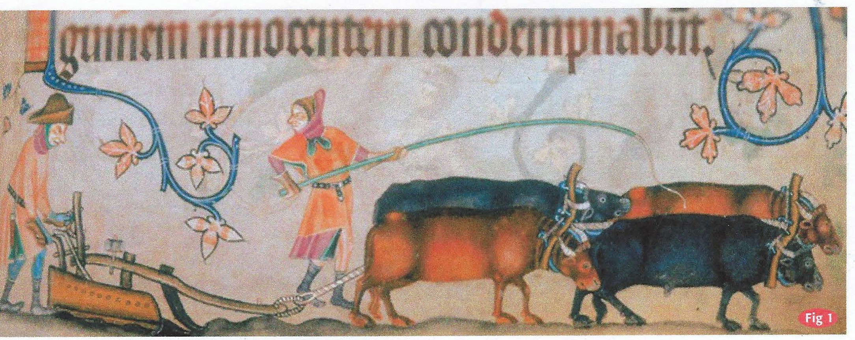

Charles Martell from Dymock in Gloucestershire is the UK,s most experienced ox trainer and driver, and perhaps better known as a maker of fine cheeses and distiller of pear and apple juice from his farm. But here he describes a cherished draught implement
The Gloucestershire Long Plough: its survival since ancient times

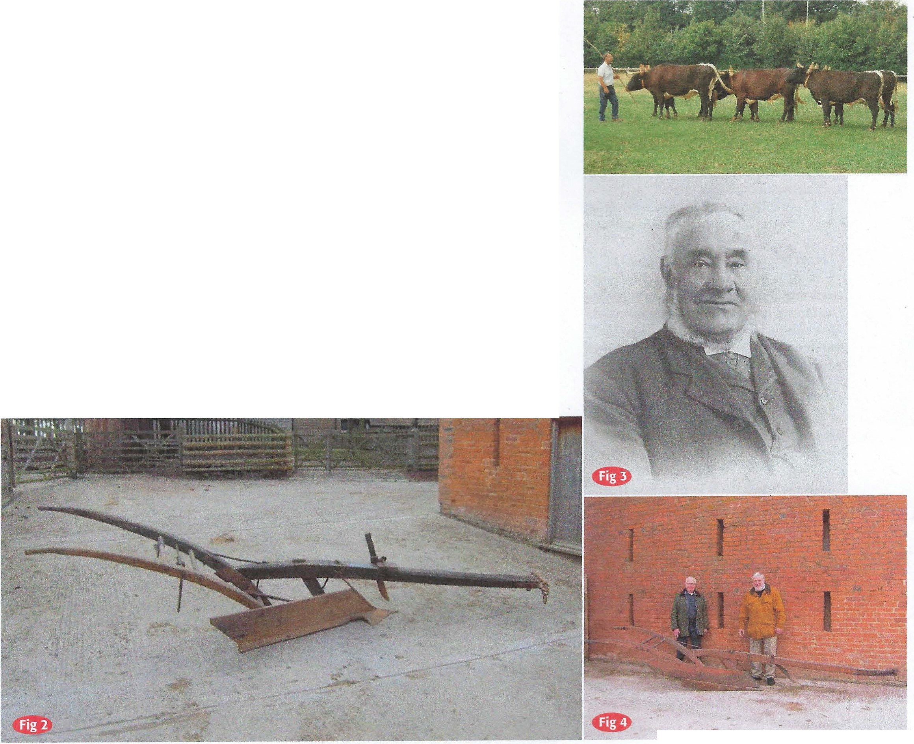
he design of the Gloucestershire Long Plough is 'medieval' and depictions of this general design
T
of plough are found in illuminated manuscripts and carved in churches (Massingham). Although rare, a few examples of the Gloucestershire Long Plough survive, mostly in private hands, and one is still in occasional use by the author. It had a major influence in shaping the landscape in which it was used - but why did this specific type of plough survive until the 20th century?
Survival
The Gloucestershire Long Plough is a mouldboard (sheldbodrd) plough and seems similar to the plough depicted in the Luttrell Psalter dated c1340. An intriguing difference is the line of black spots along the top edge of the mouldboard of the Lincolnshire-based
Luttrell Psalter plough. These may indicate nails or dowels holding a supporting piece of timber because of lack of suitable timber for the mouldboard.
William Marshall1 in 1783 and WH Pyne in 1802 were critical of the use of this type of plough which they described

Above right, Charles Martell with his six ox team at his farm at Dymock, Gloucestershire.
Fig I. Illustration from the Luttrell Psalter c 1340.
Fig 2. The 191 9 William Wyman plough.
Fig. 3. William Wyman ( 1856-1 928).
Fig 4. The 1919 William Wyman plough with (le ) William Wyman (b. 1924), grandson of the builder, and his stepson Michael.

-
62 Heavy Horse World Winter 2013

